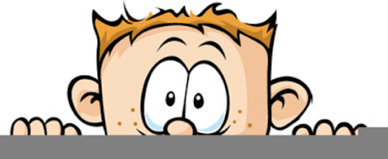

Peek at Our Week
Standard Focus | Activity | Home Extension Activity
- Demonstrates emerging problem-solving and decision-making skills  - Uses props to represent simple tools through play.  - Explores and identifies simple machines through play (e.g., ramps, gears, wheels, pulleys and levers) | Exploring ramps: The children will experiment with building ramps in the block center with different surfaces. They will record their results.  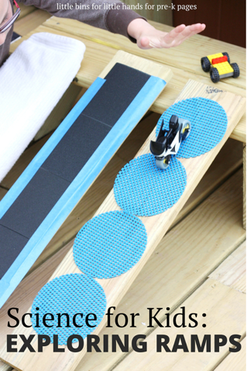 | Ramps can be made from many normal household items such as cereal boxes, wrapping paper tubes and larger cardboard boxes. Try experimenting with the height of the ramp. Record which cars or balls go the farthest and the fastest.  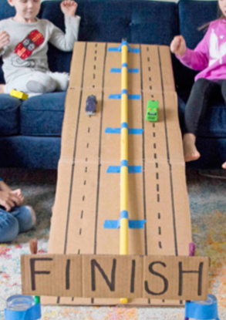  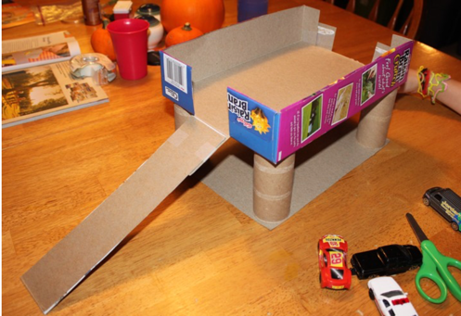  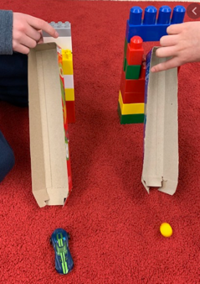
- Demonstrates emerging problem-solving and decision-making skills  - Uses props to represent simple tools through play.  - Explores and identifies simple machines through play (e.g., ramps, gears, wheels, pulleys and levers) | Exploring gears  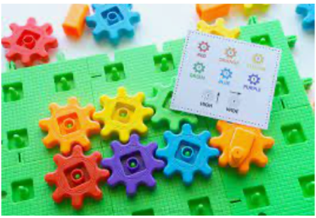 | 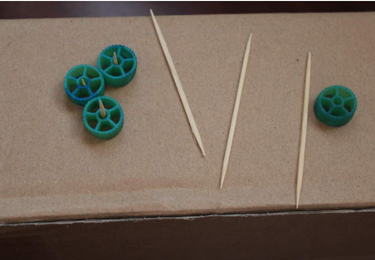  Use wagon wheel pasta, toothpicks and a box to make your own gear exploration station.
Parent Resources: Focus for the week is air travel along with ovals and spheres

