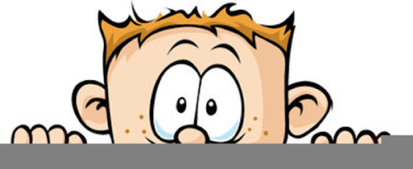

Peek at Our Week
Standard Focus | Activity | Home Extension Activity
- Explores the environment with purpose and flexibility  - Demonstrates ability to self-regulate | Mix silver and gold glitter with black paint  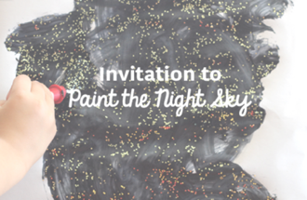 | Children love stars. Take some time and go out and look at the stars at night. You could get some star stickers and have your child put them onto black paper to make the night sky.
- Begins to describe, compare, sort and classify objects based on observable physical characteristics (e.g., color, sound, weight)  - Begins to use words to describe basic physical properties and states of matter of objects (e.g., wet/dry, hard/soft, warm/cold, firm/squishy) | 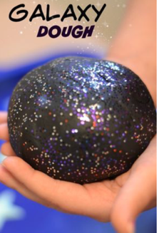 | Any kind of dough is fun for children to explore. Check out  Very Well Family for 8 playdough recipes you can make at home.
- Begins to describe, compare, sort and classify objects based on observable physical characteristics (e.g., color, sound, weight)  - Begins to use words to describe basic physical properties and states of matter of objects (e.g., wet/dry, hard/soft, warm/cold, firm/squishy) | Frozen White and Black (representing the night sky) Pom Poms  Freese white and black pom poms in individual containers, one for each child. Give each child a squeeze bottle or squirt bottle of warm water and the group some tools to share. Use these items to free the pom poms. | Playing with ice and watching it melt is always exciting. You can take any small plastic toy, put it in a small container add water and freeze it or use a muffin tin to make 12 at once! These become great bath toys. Using a turkey baster and, squirt or squeeze bottles to melt the ice gives your child a good fine motor workout!

