

Peek at Our Week
Standard Focus | Activity | Home Extension Activity
- Demonstrates knowledge related to physical science  - Begins to explore a greater variety of motions with objects (e.g., rotate, spin, twist) | 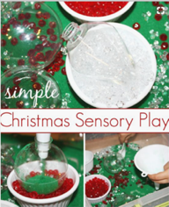  Christmas Sensory Bin | Sensory bins are easy and inexpensive to assembly. Use any shallow container and fill it with an inch of sand, rice, dried beans, small pasta. Add small toys, spoon, small plastic container and let the fun begin.
- Begins to explore a greater variety of motions with objects (e.g., rotate, spin, twist)  - Demonstrates ability to self-regulate Demonstrates increasing precision, strength, coordination and efficiency when using hand muscles for play and functional tasks  - Coordinates the use of hands and fingers | 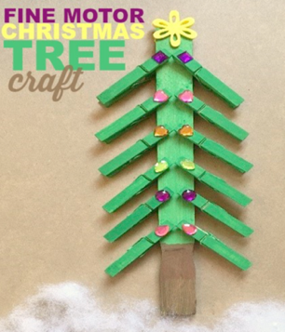 | 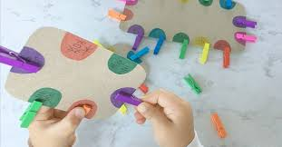  Clothes pins are a great way to exercise finger muscles. Here is a picture of a color matching activities.  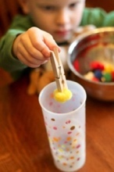  Clothes pins can also be used as tweezers.  Hang a string between two chairs and give you child some socks to hang up.
- Demonstrates increasing precision, strength, coordination and efficiency when using hand muscles for play and functional tasks  - Coordinates the use of hands and fingers | 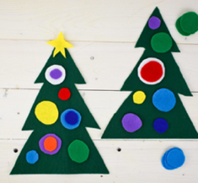  Felt Christmas Trees | 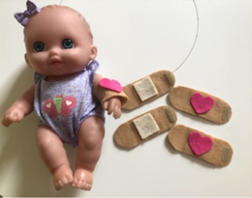  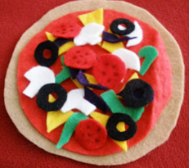  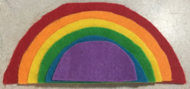  Felt can be used to make fun and inexpensive toys. Here are a few ideas: band aids for the dolls, food items to make sandwiches or pizza, and of course, a rainbow. All it takes is felt and a pair of scissors!

