

Peek at Our Week
Standard Focus | Activity | Home Extension Activity
- Demonstrates ability to self-regulate  - Begins to explore a greater variety of motions with objects (e.g., rotate, spin, twist).  - Manipulates objects by flipping, sliding and rotating to make them fit | Nut, Bolt and Washer Christmas Tree Activity  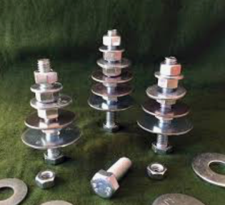 | Children love playing with tools. With adult supervision, give your child a soft piece of wood or a hard piece of Styrofoam and have them hammer large nails or screw in large screws. These activities are great for their fine motor and listening skills. This type of activity will also teach your child to be persistent because it will take them quite a few tries to master the skill.
- Asks and responds to simple questions (e.g., “Who?” “What?” “Where?” “Why?”) using gestures and two- or three-word phrases in back-and-forth exchanges | Sticker Nativity Scenes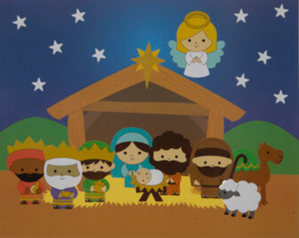 | Take some time after reading a story to ask your child who, what, where, when and why questions. Ask them to retell the story. Try acting out the story with your child or drawing a picture about it. All of these activities will increase your child’s comprehension, higher level thinking skills and love for learning.
- Demonstrates use of large muscles for movement, position, strength and coordination  - Gains control of a variety of postures and movements including stooping, going from sitting to standing, running and jumping |  | This type of game is easy to do at home. Just pick an area to focus on such as animals, season, holiday and ask your child to do different types of movement. For example, gallop like a horse, slither like a snake, move like a tree being blown in the wind. Not only do these games get your child to move in lots of different ways, they also exercise their listening skills.
Parent Resources: For the next 4 weeks, we will be learning about the birth of Jesus. The children will count down to the birth by moving Mary and Joseph along a path from Nazareth to Bethlehem.

