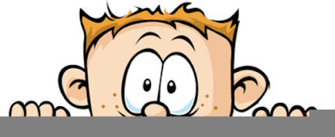

Peek at Our Week
Standard Focus | Activity | Home Extension Activity
- Explores own environment  - Shows increased eagerness and curiosity as a learner | 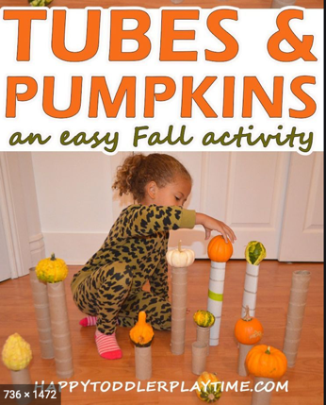 | Balancing objects exercises your child’s gross and fine motor skills, requires planning, persistence, and self-control. Look around your house and see what items you can stack and balance. Be creative!
- Recognizes a simple AB pattern (e.g., clap/snap, clap/snap, clap/snap) | Use green pipe cleaner and orange buttons to make pumpkins on a vine. | Buttons are a great item to use for stringing and pattern making. Large bags of assorted color and size buttons are available to Walmart and on Amazon. You string onto pipe cleaners, yarn or thin shoes laces.
- Begins to use senses to observe and experience the environment | Exploring the differences between apples and pumpkins | Bring your child into the kitchen when you cook and let them see, smell, touch and explore the different ingredients use for a meal. Children are more likely to try a new food if they helped to prepare it.
Parent Resources:

