

Peek at Our Week
Standard Focus | Activity | Home Extension Activity
- Recognizes a simple AB pattern | Make patterns with apple cards. | Lots of different items you have at home can be used to make patterns such as fork, spoon, fork, spoon or shoe, sock, shoe, sock. Look around the house and get creative!
- Uses imagination and creativity to express self through open-ended, diverse and process-oriented art experiences with intention  - Begins to use senses to observe and experience the environment | 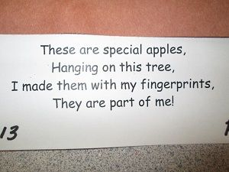  Print a tree with this poem on the bottom of the page. Have the children make green, red and yellow “apple” fingerprints. | Finger painting is fun and does not require special paints. Any washable paint will work. Take a cookie sheet and pour some paint in it. Have your child use their hands to move the paint around. When they are done, take a plain piece of paper and put in on top of the paint and press lightly and then lift if up. You will a print of the markings in the paint to save and hang up.
- Continues to engage in parallel play but also begins to play with other preferred playmates | The large sensory bin will be filled with apple pie scented oatmeal and the small sensory bin will be filled with split peas and garbanzo beans died to look like pumpkins. | Sensory bins are easy to make and provide great experience for your child. Use any shallow container, a box, plastic bin, or metal baking pan. Fill it about halfway with oatmeal. Add a small amount of any other small objects to the bin such as, mini erases, pasta, magnetic letters, plastic animals or jewels to the containers. Give your child some small containers, tweezer/tongs, measuring spoons and let them discover and explore. Use your imagination when setting up sensory bins, there is no right or wrong way of doing it.
Parent Resources: Our focus this week is taste.

