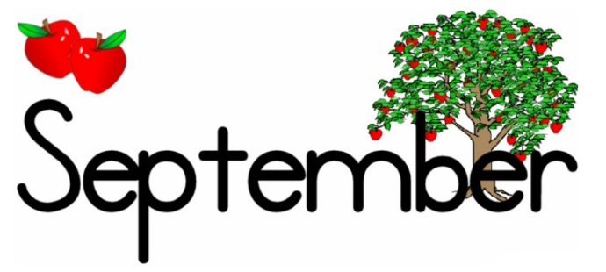
Pre School II
We have made it through the first couple of weeks of school! What a wonderful group of children we have! We had a great summer filled with lots of water play and learning.
So far, we have been concentrating on rules and procedures. It has been a lot for the children to take in, but they are adjusting very well. We will continue working on rules, procedures and transitions from one activity to another. Please talk with your child about using an inside voice and being a good listener. This will help reinforce what we are practicing in the classroom.
Each morning, at circle time, we talk about letters and their sounds. We work on letter concepts every day and try to incorporate it throughout the day in all activities. You may help your child at home as well by identifying letters and sounding them out. The curriculum is carefully selected by our staff to meet preschool standards. We target skills in each area of child development, including physical development, social/emotional well-being, language/literacy, science, health/safety, math, and fine arts.
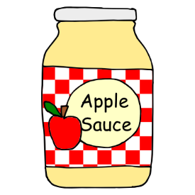
This month our theme will be Johnny Appleseed/Apples. We will be reading stories and teaching children about apples and their many uses. We will go over the anatomy of apples and discuss their life cycle. In addition, Sister Donna will be cooking applesauce with the children!
We would like to give a special “thank you” to all our parents for the beautiful flowers that we received. We appreciate all of you, and look forward to a wonderful year with you and your child!
Thank you,
Ms. Angie Ms. Eloisa Ms. DaVasha

