A little bit of Fall is finally in the air! It feels so good to go on our buggy rides with a nice breeze. The babies just love their outdoor time.
We will be using fall colors as we paint and make our projects for Thanksgiving. We will be sending home a I am special poster with your child. Please be creative and do it so we can hang them up through the room and learn about our babies Family’s. They will enjoy looking at them all month and seeing their Family members on them. Please add pictures, pets, favorite foods, whatever you like. Return as soon as possible.
We will make Turkey hands and sing our Turkey songs. Also make special cards for our parents. Don’t forget our Thanksgiving luncheon. Please join us if you are able. We will continue to work on our gross motor skills by practicing crawling, pulling up, standing, and walking with help.
Please have a Wonderful Thanksgiving time with your Family. Thank you for your donation of wipes each month. If you have any questions, feel free to ask.
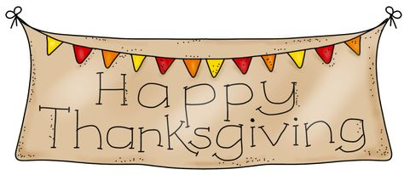
Thank you.
Mrs. Linda
Ms. Maryanne Ms. Katelyn
Ms. Emilee

