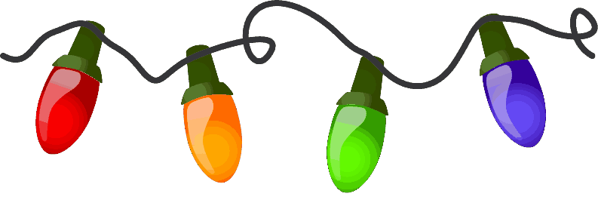
It is so hard to believe this year is almost over. This month our focus is on Advent and the whole birth of Jesus story. Each week, we will focus on our Advent wreath and calendar as we move closer to the birth of Jesus.
Happy
The first week we will be reminded of the light of hope that the prophets had as they looked forward to Jesus who would be bring peace and love to our world.
The second week will remind us of the dark night when Joseph and Mary found light and warmth in the stable.
The third week reminds us of the love and joy which surrounds the shepherds at the announcement of the birth of Jesus.
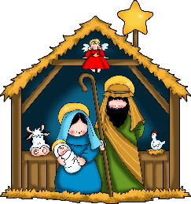
The fourth week will be the star which guided the three wise men to the stable. We will be making the passage of time during the four weeks of Advent.
We will be sharpening up out counting and math skills starting by, counting the days till Advent. We also introduced to the children numbers 20-30. Our math and counting board now reflect numbers 1-30
For kindergarten, we are developing the Cognitive Development Domain. This domain reflects the child’s ability to learn and solve problems. Cognitive and General Knowledge includes early mathematics and early scientific development.
This month, the children will be learning about gift and cards, cookies, ornaments, Advent, Christmas around the world, polar express and our Christmas program. In our Bright Beginnings curriculum, we will be learning about Advent with weekly visits to church. We will read the bible verses that lead up to the nativity and Christmas songs.
Important Dates
December 6th (5:30 – 9 pm) Parent Appreciation Night
December 12th is our VPK Christmas program
December 13th St. Lucia Day
December 14th Christmas Around the World (Dress in traditional clothing or Christmas colors)
December 21 VPK Christmas Party
December 24-January 4th No VPK
Mrs. Ida Marchitelli
Miss Riley Roberts Ms. Heather Burney

